Accommodation

We have organised accommodation for everybody in the Lenton and Wortley Hall. The hall will provide breakfast for residents as well as dinner for the conference participants. It is located a few minutes walking distance away from the School of Mathematical Sciences building. On the University Campus map, Lenton and Wortley Hall is situated near building 52. In case of late arrival, there will be a number on the main porter lodge that can be called. A member of the staff will come and provide you with your room keys. Guests can check in 24 hours with a member of the hall staff being on site until midnight and then the call will direct to security after this time.

Please note that you can get to the Hall either via Derby Road or Beeston Lane. Also, note that there is a tiny walkway (yellow arrow) connecting the Hall Offices (close to Derby Road) to the bus stop (Lenton UN13) in A52:

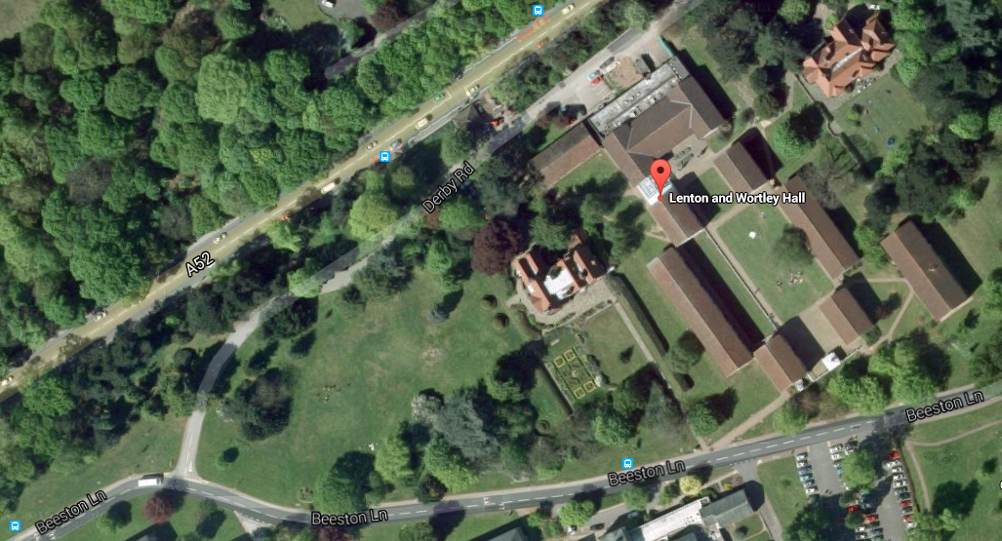

A view from the upper bus stop (direction: Nottingham city centre) towards the walkway passage is shown below:

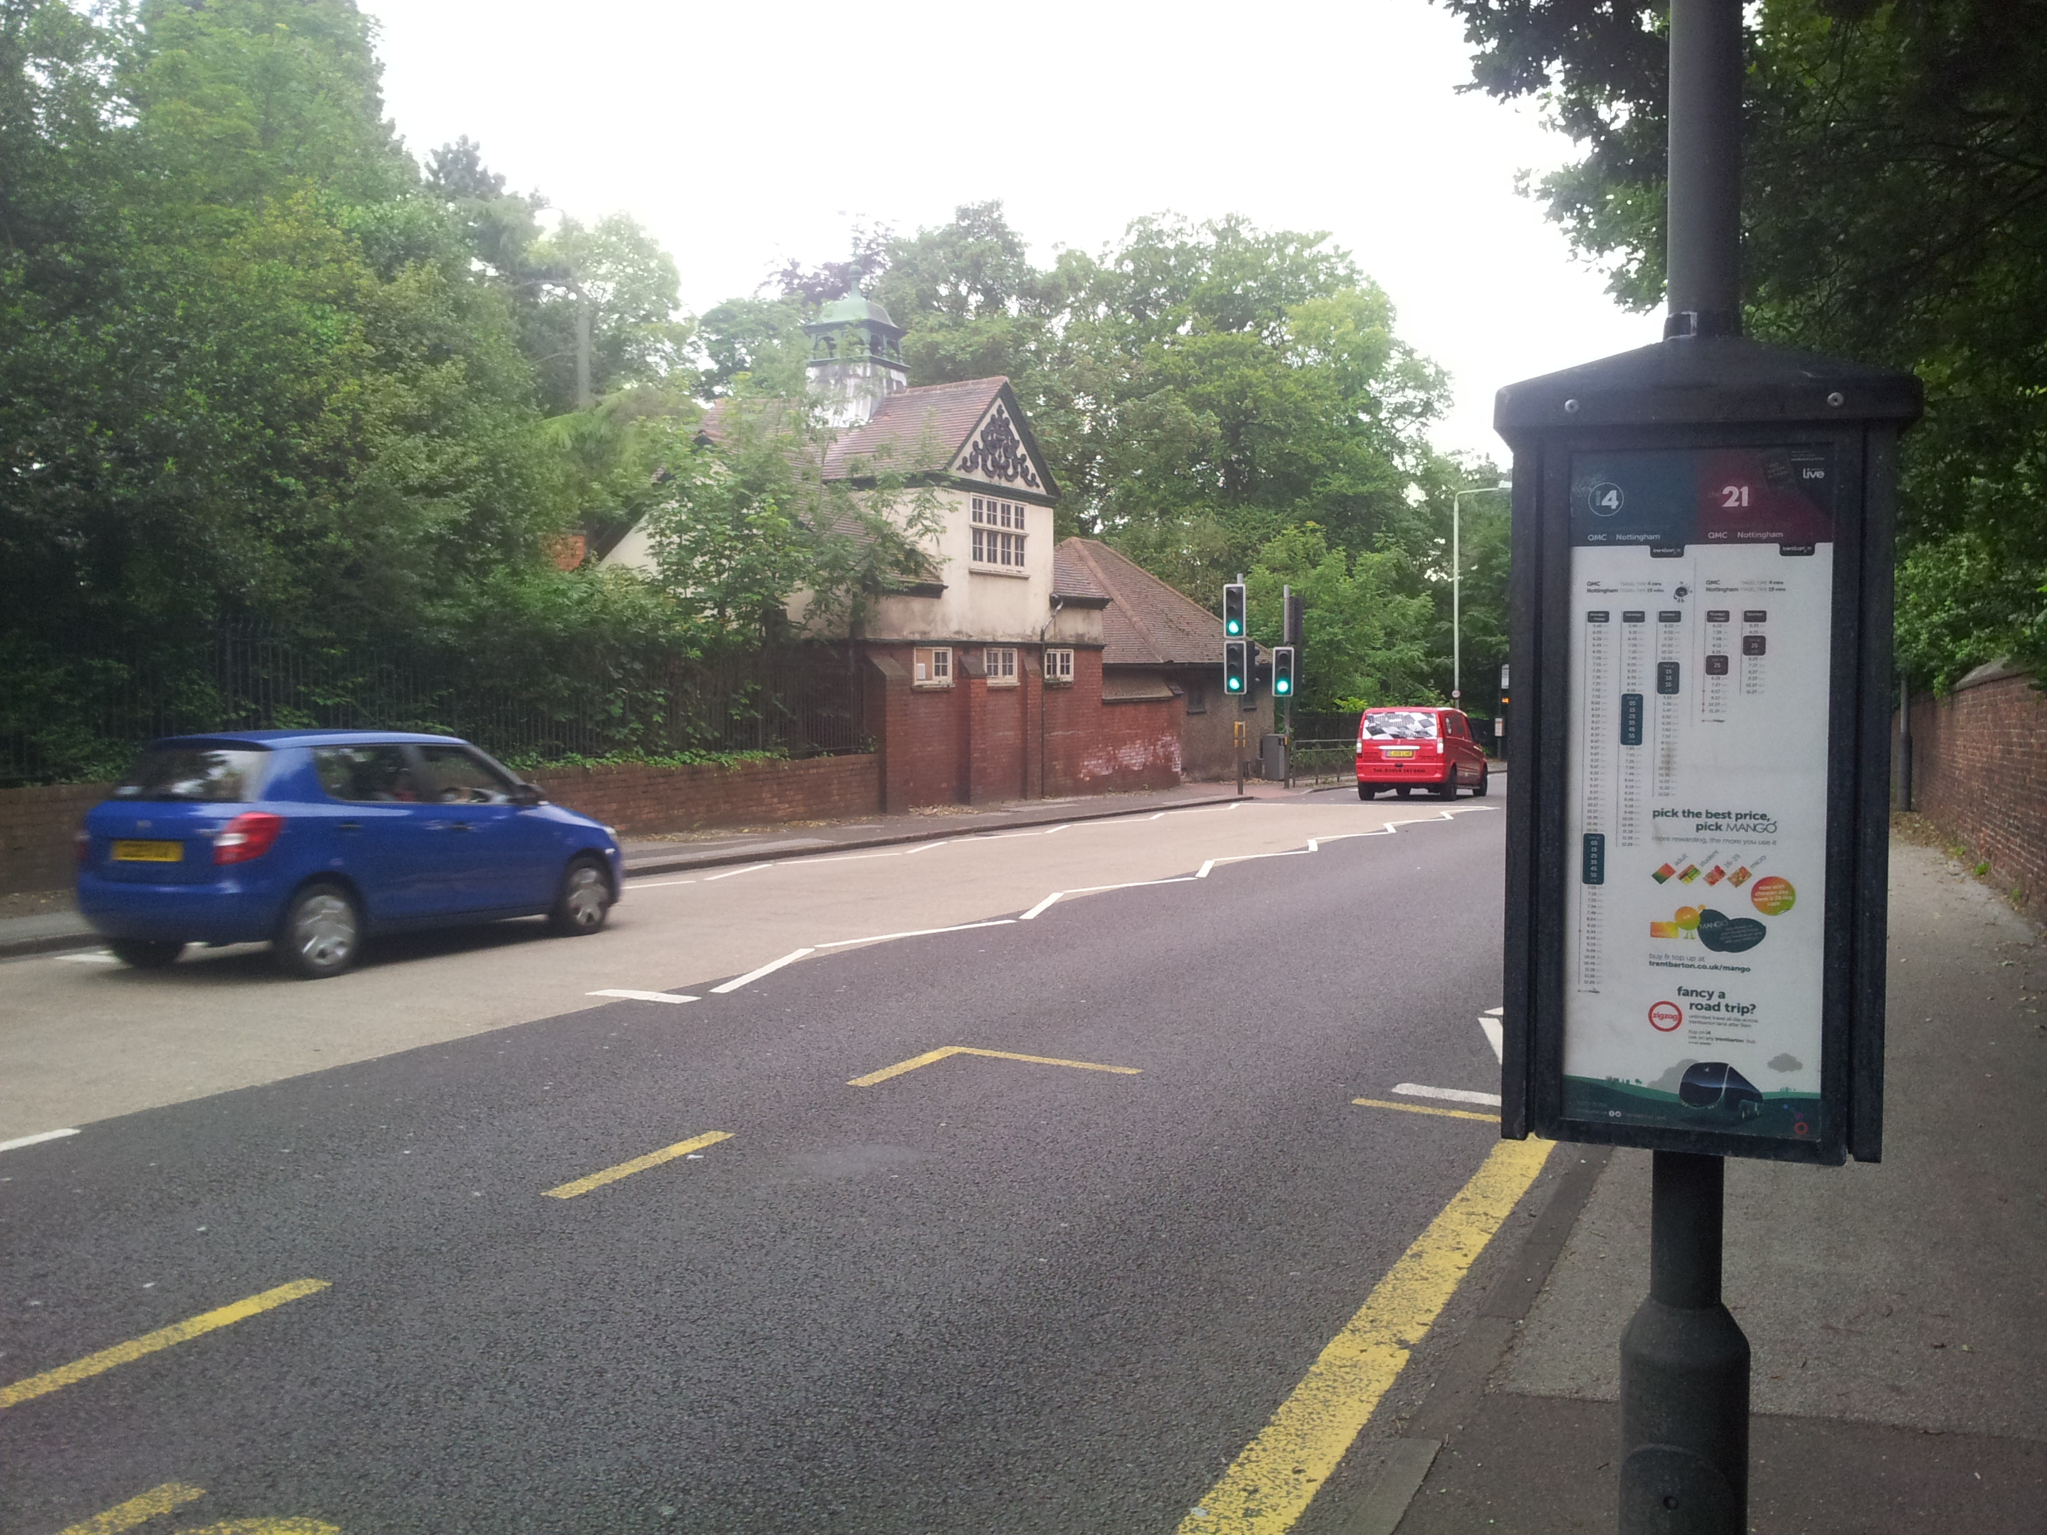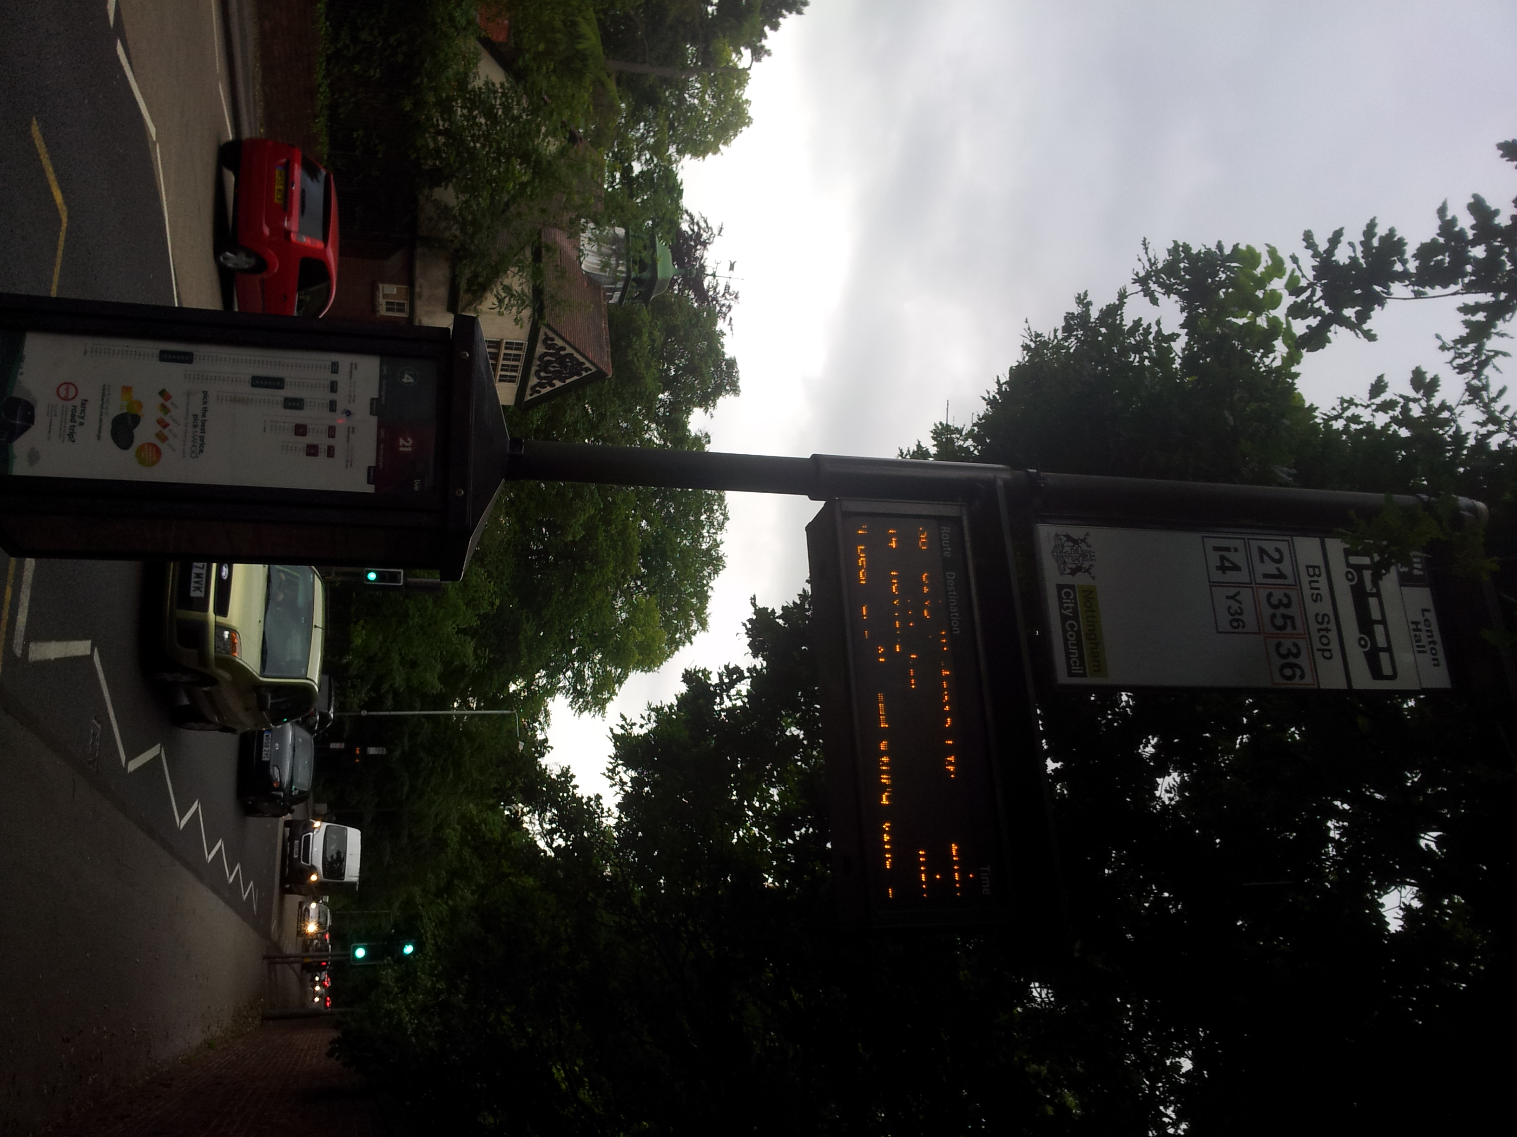

Travel
The new School of Mathematical Sciences Building is located on the main campus, University Park Campus (building no. 20 on the University Campus map). The talks will be in Nottingham Lakeside Arts Centre (building no. 50, Lecture Theatre room A30) next to the Music and to the Psychology Buildings. An overview how to get to the University Park Campus is available on the following pages.
Flights: the best option beside East Midlands Airport (EMA) is Birmingham International and Stansted Airport. Birmingham International (BHX) Airport is a 45-minute taxi ride (£56) or 1 1/2 hour train ride away from Nottingham. From Stansted Airport (STN), you best take the train via Ely and Peterborough, which is not too expensive (always buy return tickets which are often much cheaper than two singles). This journey takes 3 hours, but it is through nice countryside. Train tickets can be booked through http://www.nationalrail.co.uk/.
A number of bus services run from the city centre to the University campus at University Park. There are buses from Nottingham train station and buses from East Midlands Airport.
An electronic journey planner can be found on www.travelineeastmidlands.co.uk. Note that at bus stops, you need to put out your hand to indicate to the driver that you want to use this bus.
If you have a late evening/night arrival flight, we suggest to pre-book a taxi well in advance. For information on taxis, see below.

Buses:
- From Nottingham train station
For University Park campus, the bus stops closest to the train station are Broadmarsh bus station (for Trent Barton's Indigo and Sky-link services) or Canal Street (for Nottingham City Transport's 13 and 14 services). Get off the bus at ``University south entrance".
www.trentbarton.co.uk/services/indigo

www.trentbarton.co.uk/services/skylinknottingham

www.nctx.co.uk/lines/maroon-line

- To/From Lenton Hall bus stop
Bus routes to and from the Nottingham city centre serving the Lenton Hall bus stop are 21, i4, and Indigo.

Taxis
Avoid rogue and unlicensed taxi drivers (Nottingham City Council licenses two types of vehicles: Hackney Carriages and Private Hire vehicles). Hackney Carriages can be hailed in the street, Private Hire vehicles need to be pre-booked.
We recommend the following taxi companies in Nottingham:
1) DG Cars (+44115 9 500 500 or +44115 9 607 607)
2) Yellow cars (+44115 9 818 181 or http://www.yellowcars.net)
3) Cable Cars (+441159229229)

From the Lenton and Wortley Hall to the Arts Centre
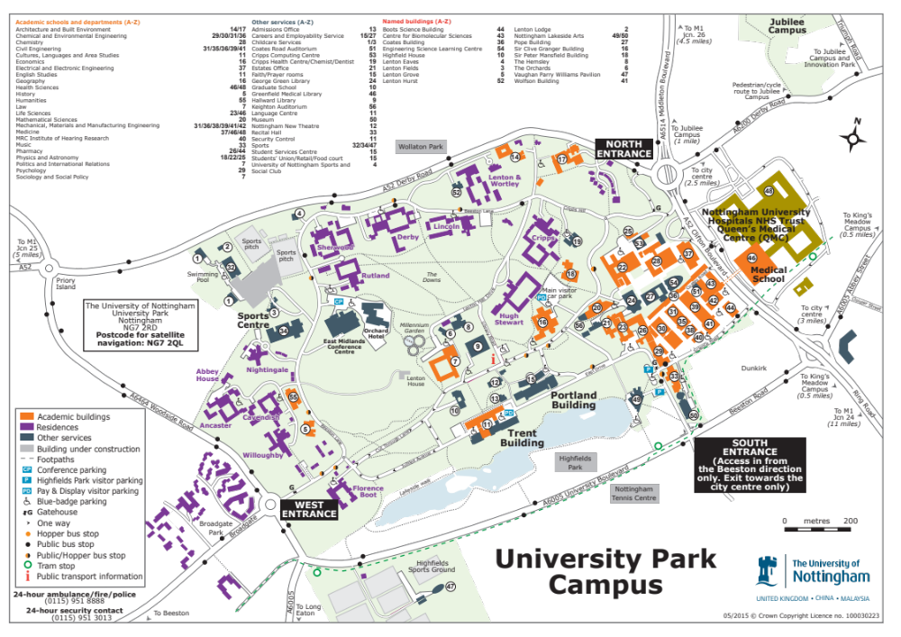
Directions:
From Beeston Ln take the walkway down to Lenton Hall Drive, pass by the Cripps Hall and carry on between the Main Visitor Car Park and the Sir Peter Mansfield MRI Centre (Building 18). Go towards the Maths Sciences Building (no 20) and head to the lake (direction Portland Building). Walk along East Drive towards the South entrance. You will find the Arts centre on your left.

Please find a larger map at:
https://www.nottingham.ac.uk/sharedresources/documents/mapuniversitypark.pdf

-- Quiz: do you recognize any Nobel Prize on your way? --

